ECONOMICS

LEVEL 1

ACHIEVEMENT STANDARD AS90983

CREDITS – 4
External

Demonstrate understanding of consumer choices, using scarcity and/or demand

Achievement Criteria

Achievement | Achievement with Merit | Achievement with Excellence
- Demonstrate understanding of consumer choices, using scarcity and/or demand. | - Demonstrate in-depth understanding of consumer choices, using scarcity and/or demand. | - Demonstrate comprehensive understanding of consumer choices, using scarcity and/or demand.

Notes available: www.economics.org.nz

Part One
Scarcity, Choice and Opportunity Cost.
Objectives:
- Understand the conflict of limited means relative to wants, and see the relationship between limited means and the need to make decisions.
- Explain the concept of choice and the opportunity cost that occurs.
- Recognise that different groups bring different values to the decision making process.
SCARCITY
Economics is the study of how individuals and groups choose to use scarce resources to satisfy unlimited wants.
People are naturally greedy and want as much as they can get – people have
unlimited wants
However people only have limited means to satisfy their unlimited wants – people have - limited means .

People’s means is a term that refers to people’s ability to satisfy their unlimited wants.
People’s means include
- Time- the time they have available to fulfil their needs and wants.
- Income, the money they have available to fulfil their needs and wants. Income can be earned from wages, fees, commission, royalties and capital gains.
- Skills / attributes, people’s personal abilities and potentials, we are all born with different attributes and education and training help us to realise our true potential.
- Means can also take on a cultural aspect. Some groups would also include extended family as a means.

Limited means includes not having enough…….

Time
Income
Skills

People’s means are limited – they don’t have enough to get all the goods and services they would like. Even the richest person in the world has limited time to do all the things they would like to do.
Because of unlimited wants but limited means we have SCARCITY.
Limited Means

= Scarcity

Unlimited Wants

Scarce goods are termed economic goods, with more people wanting them than can afford to acquire them.
Some goods are not scarce in relation to wants – these are called free goods.
Types of goods

Free Goods
- Sunshine
- Wind
- Sand
Economic Goods
- Goods that are scarce and we have to pay for them.

Consumer Goods.
Goods use by consumers for their personal satisfaction
Capital Goods.
Man made goods used to produce other goods.

NEEDS AND WANTS
Needs are things that we have to have to survive, such as food, water, warmth and shelter. Needs are the basics of life.
Wants are things that we desire. Everything that is not a need can be classified as a want – including luxury items.
What constitutes a need or a want can change according to circumstances and time. Modern items such as electricity are now seen as a need, but before they would have been seen as a luxury item.

HAVING TO MAKE CHOICES

OPPORTUNITY COST IS the next best alternative forgone. This is what has to be given up because of the choices we have made.
E.G. If Nick is making a decision about what to have for breakfast – he likes porridge but really loves weetbix, he could also choose toast with marmite. If he chooses weetbix then the opportunity cost is the porridge – because this was the next best choice forgone.
Consumer decisions are influenced by

Our Limited Means

Time
Income
Skills

QUESTIONS: Use the information below to answer the questions which follow.
Answer all questions in the spaces provided.

- Describe the link between the economic ideas below.

SCARCITY CHOICE OPPORTUNITY COST
Because of unlimited wants but limited means we have scarcity, which means that we have to make choices about what we would like to have. With every choice we make there is an opportunity cost – this is the next best alternative forgone ( what has to be given up).
- What is the economic problem that requires people to make choices? Scarcity
- Dean has to choose between going rafting, snowboarding or fishing. He considers fishing as the most desirable activity and snow boarding the least desirable. Explain the opportunity cost concept. D E R Opportunity cost is the next best alternative forgone. If he chooses to go fishing then rafting is the opportunity cost because this is the next best alternative forgone.
- Consumers make choices about what to do. Why can’t they have everything they want? Because of limited means.
- What are limited means and how does this affects us? Limited means are our scarce resources and personal attributes. OUrlimited means are our limited time, income and skills and for some groups family.
- Complete the sentences below.
a) A key idea expressed in Economics is that S
R have alternative uses.
b) All economic goods and services are S in relation to W
c) Scarce means resources are fewer than people’s W .
d) Consumers make decisions based on L
M
e) The R C for a council developing a park is other goods and services that could be produced with the same resources.
f) C goods will increase a country’s future production.
g) There will be an O C with every choice made.
- a) Divide the following in to free goods or economic goods.
TV moon food boat sunshine sand tea
Car stars clothes clouds wine sea ice

Free Goods | Economic Goods

- What is the difference between free goods and economic goods? Free goods are abundant and so we don’t have to pay for them. Economic goods are scarce and so we have to pay for them.
- What is meant by consumer goods? Goods used by consumers / households for their personal satisfaction.
- A survey of consumers showed their buying preferences for Easter Eggs.
The results of the survey were:
First Choice | Percent of people surveyed
Caramel eggs | 45%
Marshmallow eggs | 30%
Hollow eggs | 25%

a) Use the information above about Easter eggs to explain the concepts of choice, opportunity cost and scarcity, and then explain how they are linked.
i) Choice Because of their unlimited wants but limited means people must make a decision and choose which type of egg to buy – they can’t have them all.
ii) Opportunity cost If people choose to have caramel eggs then the opportunity cost will be the next best alternative given up – in this case the marshmallow eggs.
iii) Scarcity due to unlimited wants but limited means people can’t have all the eggs they would like to have. There is scarcity – a limited supply of Easter eggs and a limited ability for people to be able to buy them.
iv) Links between the concepts because of scarcity people can’t have all the eggs they would like to have so they have to make a choice about what they want to buy – if they choose to buy caramel eggs then the opportunity cost is marshmallow eggs, this is the next best alternative forgone.

11. Using the ideas of needs and wants limited means and unlimited wants, explain what scarcity means.

People / society have unlimited needs and wants but limited means (resources, time, income and skills) so there is scarcity – there is a limited amount of resources in the world and so choices have to be made about what to produce.
12. Explain the connection between scarcity, choice and opportunity cost.
Because of scarcity choices about what to produce have to be made, with every choice made there is an opportunity cost – something has to be given up.
THE INFLUENCE OF VALUES ON DECISION MAKING.
What are values? Values are what people feel are important. These are strongly held beliefs or principles. Values are things that affect our everyday decision making. They are our core beliefs and principles. They influence what we will buy and what we will or won’t do.

There are many different values, but some of the main ones are:-
- Honesty.
- Integrity – someone who has honour, someone who can be relied upon.
- Fair dealing – a belief that justice is important. Someone who does not rip people off and who does not take advantage of people.
- Consideration of others – someone who is thoughtful, who thinks about other people. People who are considerate have compassion, respect, concern, courtesy and kindness towards other people.

Several things affect our values, but the major ones are:-
- Upbringing – how we were brought up (the influences of the people who raised us).
- Culture – different cultures have different beliefs.
- Religion – different religions have different beliefs about what they can and cannot use.
- Gender and age- what stage of life we are at will have a profound effect on the decisions we make.
- Friends / Peers – people we associate with affect our behaviour.
- Income/wealth – the level of income we are on often affects the way we think and behave.
- Social grouping – which social group we most closely identify with will affect how we act and the values we have.
- Media – this includes movies, radio, television, newspapers, magazines etc.
A TALE OF TWO CULTURES.
Consider the story of two different families, one from Scotland and the other from Samoa, that moved to New Zealand in the 1950’s. The Scottish family came from a harsh agricultural environment that required people to plan ahead, save carefully, collect food and fuel in summer and store it for use in winter. In winter they were snowbound for two months and if they were not prepared correctly they would perish.
On the other hand the family from Samoa came from a warm environment where they could harvest food or go fishing all year ‘round. If a tropical storm ruined their house, it could be easily rebuilt as resources were plentiful. There was little need to plan ahead. Most foods could be not be stored because they had a very short “shelf life” in the hot temperatures. In fact it would be unwise to store the food. People in New Zealand thought the Scots were too serious and frugal; paranoid about being well-prepared and unable to ‘let their hair down’. The Samoan family were seen by some as relaxed to the point of being lazy; too carefree and irresponsible because they didn’t plan for the future.

QUESTIONS:
- Describe the different environments these families come from.
- Explain how these different environments might influence the upbringing and culture of these families. Describe Explain Relate
- What does this story tell us about how culture and upbringing affect our values?
- When arriving in New Zealand why don’t the families change their approaches to planning?
- From your everyday life, think of other examples which show how different people have different values.
- Read the case study below and then answer the questions.
THE POWER OF MODELLING
There was once a little boy who lived with his parents and grand parents in a farming community. During his pre-school years the little boy spent much of his time “helping” his grandfather who had only one arm. His grandfather was able to tie the laces on his work boots using only his left hand. The old man died when the boy was six years old. It is interesting to learn that as an adult the boy (while able bodied) would tie his boot laces using only his left hand.

i) What is the link between this story and the way people gain values?
7. Match the terms with the phrases.
TERM | Match | PHRASE
1.Values | D | a) The attitudes and actions of our friends which influence us.
2. Honesty. | G | b) Thinking of what others may need or want.
3. Peer pressure. | A | c) a system of practises that are developed by a group of people that ensures their on going survival and sense of identity.
4. Integrity | E | d) The principles and important beliefs by which we live.
5. Upbringing. | F | e) Upright, virtuous and reliable.
6. Consideration. | B | f) In many ways people follow the principles by which their parents and grandparents lived.
7. Culture. | C | g) telling nothing but the truth.

HOW DO VALUES AFFECT THE CHOICES WE MAKE?
Values affect what people will buy or the services we use. Some people will not use certain goods because their religion of culture don’t allow it.
Cows in India are considered to be sacred animals and people won’t harm them. Indian people who believe in the Hindu religion will not eat cow meat (they have no demand for cow meat) their culture and religious beliefs have affected their demand for a good.
More recently some people don’t believe in the genetic modification of food (GE food) and so won’t buy any product that they believe to be genetically modified; they have no demand for this kind of food because of their beliefs.
Can you think of any other examples of people’s values affecting their choices for a product?

- Fill in the blanks using the words below.

Values scarcity culture
Unlimited wants choices scarcity
Choice alternative upbringing
Integrity limited means honesty
Opportunity cost decisions decisions
Values consideration of others

Scarcity occurs because of people’s _UNLIMITED WANTS____________ and LIMITED MEANS___.
_Scarcity _ is the main Economic problem. Because of the problem of _scarcity people have to make _choices_, with every _choice_ they make there is always an
opportunity cost_. This is the next best _alternative_ forgone. Because we have to make choices we need to make _decisions_, the _decisions_ we make are influenced by our _values_, these are things we hold to be important. Examples of the _values we hold are things like _integrity_, __honesty_ and consideration of others.
The values we hold are often influenced by things like our _culture_ and _
upbringing._.
- In what way can advertising affect our values? Advertising affects how we behave by trying to influence our opinion. It often uses famous people who may have influence over our opinions to promote a product. The way in which the product is promoted i.e. using sex in advertising may influence the values of the people who watch it.
- Define a person’s means time, income and skills are a person’s means. These are what a person has to try and satisfy their unlimited wants.

A major oil company hopes to build a big new petrol station on a public reserve. The reserve is in a housing area that is on Jacki’s way to work. It is also a historic pa site. People have different points of view or attitudes about this idea. This shows they hold different values.

- How could values influence the decision to build the petrol station..
Describe People make decisions based upon their different values

Explain Values are things we hold to be important. And are influenced by culture, religion, upbringing etc. Some people will value culture and history while some people might value progress and convenience.
Relate So some people may value keeping the historic Pa site while others may value having a new petrol station – they have different opinions based on their values.

13. Identify three factors that influence the values people hold.
i) Culture, religion, family, friends, gender, income etc.
ii)
iii)

14. Using the example of the proposed petrol station, explain how all economic decisions have an opportunity cost.
If the petrol station is built then there will no longer be a reserve there and so there is the opportunity cost of the loss of the land for public use.

15. What is the economic term that describes the condition of limited resources relative to wants?
Scarcity

17. List six values a person may hold. Honesty, integrity, consideration of others, respect, fair dealing, kindness.

18. Tui Wilson is a fit and healthy 16 year old. Her 35 year old brother, Ben, is a plumber and is married with 2 young children. Tui’s sister, Chrissy, is studying medicine and does voluntary work in a busy public hospital. The Wilson family is part of a large whanau.
a) Describe one way the Wilson family might help to meet their needs. A person’s means includes their whanau and so they may be able to help with income or helping out with time etc.
19. Tui, Ben and Chrissy have been invited to spend the weekend at a whanau gathering, Ben is keen for himself and his family to spend time with the whanau, but Tui and Chrissy cannot decide.
a) If Tui and Chrissy spend the weekend with the whanau what is the economic problem shown (Fully explain why Tui and Chrissy cannot attend the gathering and meet their other needs and wants).
Describe Tui and Chrissy can’t do everything they would like to do.
Explain There is Scarcity – due to unlimited wants but limited means (in this case time) they have to make a choice about what they would like to do – with every choice made there is always an opportunity cost.
Relate Chrissy and Tui have Scarcity – they have unlimited wants going to the gathering or doing other things, but only limited time and so they must choose an option. If they choose to go the gathering then there will be an opportunity cost such as studying for Chrissy.
20. At the gathering, the kaumatua (elders) discuss values that people have.
a) Choose one of the three Wilson’s and identify a value they may hold.
Name of Person Chrissy
Value held by that person Consideration of other / kindness.
b) Explain why they may hold this value Due to her upbringing and / or religion which impact on what she holds to be important and the way in which she thinks, she may have been taught to value other people and to help people who are less fortunate and so she is considerate of others.
c) What is the link between the value they hold and an economic decision they may make. Describe Values are things we hold to be important. Explain Values such as consideration for others, honesty etc. affect the decisions we make. Our values are influenced by such things as our culture and upbringing. Relate Due to her upbringing Chrissy has the value of consideration of others / kindness and so she feels she should help out. She has decided to give up some of her time and volunteer at a hospital. The opportunity cost of this decision might be less time to study.
21. Simpson’s Video
The characters on the Simpson’s behave in a range of predictable ways that reflect the value positions that they hold.
For each of the characters identify

- A key value (or lack of value) which influences their decisions.
- Provide an example of a decision they have made that illustrates the value you have noted.

- Bart’s key value / lack of value
Example of a decision
- Homer’s key value / lack of value
Example of a decision
- Lisa’s key value / lack of value
Example of a decision
- Marge’s key value / lack of value
Example of a decision
- Flander’s key value / lack of value
Example of a decision
- The Coach’s key value / lack of value
Example of a decision
2. Name some of the things that affect the values you have mentioned above for the characters.

PART 2

DEMAND FOR GOODS AND SERVICES 1.1
OBJECTIVES:
- Describe the influences that effect the demand for goods and services.
- Draw a demand curve for an individual from given data.
- Explain that market demand is the sum of the individual’s demand schedules.
- Draw a market demand curve.
- Explain and illustrate a movement along the demand curve.
- Identify the causes and evaluate the implications of a shift of a market demand curve.
- Explain and illustrate how consumers will react to changes other than price.

FACTORS INFLUENCING THE DEMAND FOR GOODS AND SERVICES.
FACTORS INFLUENCING THE DEMAND FOR GOODS AND SERVICES INCLUDE……….

PRICE
INCOME
TASTES
PRICE OF OTHER GOODS AND SERVICES

SUBSTITUTES
COMPLEMENTARY

INDIVIDUAL DEMAND SCHEDULE AND CURVE

Individual consumer demand refers to THE QUANTITY OF A GOOD / SERVICE A CONSUMER IS BOTH WILLING AND ABLE TO BUY AT A CERTAIN PRICE
Consumer demand is like a want backed up by the ability to pay.
An individual’s demand curve can be plotted form the data contained in the demand schedule.
An individuals’ demand schedule is A TABLE THAT SHOWS THE QUANTITY OF A GOOD / SERVICE A CONSUMER WILL PURCHASE AT A CERTAIN PRICE.
It assumes CETERIS PARIBUS
Which means that all other factors that may influence demand are held constant.
This is done so that we can clearly see the relationship between price and the quantity demanded.
MATTHEWS DEMAND SCHEDULE FOR ROCKYROADS
PRICE ($) | QUANTITY DEMANDED (QD)
1.00 | 10
1.20 | 8
1.40 | 6
1.60 | 4
1.80 | 2

As we can see an increase IN PRICE WILL LEAD TO A DECREASE IN THE QUANTITY DEMANDED – ASSUMING CETERIS PARIBUS.
This is the first law of demand – an increase in price will lead to a decrease in the quantity demanded assuming ceteris paribus.
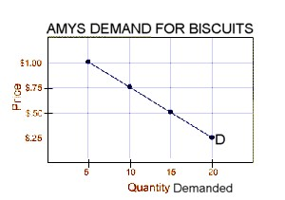
As can be seen in the above diagram the demanded curve is downward sloping to the right meaning that a decrease in price will result in AN INCREASE IN THE QUANTITY DEMANDED.
So any change in price will result in A CHANGE IN THE QUANTITY DEMANDED – ASSUMING CETERIS PARIBUS, ALL OTHER FACTORS REMAIN UNCHANGED – ONLY PRICE CHANGES.
Reasons why people buy more at a lower price include
- The consumer can now afford to buy more of the cheaper good.
- Other goods become relatively more expensive and so the consumer will buy more of this good.

MOVEMENTS ALONG THE CURVE
A movement along the demand curve will only result from a change in price. (assuming ceterus paribus). A decrease in price will result in AN INCREASE IN THE QUANTITY DEMANDED – ASSUMING CETERIS PARIBUS.
A DECREASE IN PRICE
P($)
To show a decrease in demand you need to clearly show the changes. Label the initial price P and the price after the change P’. The change in price has lead to an increase in the quantity demanded from Q to Q’
4

P1 3

2

P2 1
D
0 2 4 6 8 10 12 14 QD
Q1 Q2
Remember to draw a line from the axis to the demand curve to show the change.

In the situation above a decrease in price has lead to a movement along the demand curve and an increase in the quantity demanded.

QUESTIONS:
1. From the following demand schedule construct a demand curve.
GRIM’S DEMAND SCHEDULE
FOR GUMIBEARS.
PRICE ($) | QUANTITY DEMANDED
1.00 | 15
1.20 | 12
1.40 | 9
1.60 | 6
1.80 | 3

2. On the demand graph you have drawn clearly show what happens if there is an increase in price from $1.20 to $1.60.
3. Complete the following sentence.
An increase in price will cause a mOVEMENT along the curve and a dECREASE in the qUANTITY dEMANDED
A decrease in price will cause a MOVEMENT along the curve and an INCREASE in the QUANTITY DEMANDED
4. From the graph below create a demand schedule.
BILLY’S DEMAND SCHEDULE FOR CHIPS
P($) | QD
2 | 10
4 | 8
6 | 6
8 | 4
10 | 2

5. Draw a demand curve from the following data.
GOHAN’S DEMAND SCHEDULE FOR DRAGONBALLZ TOYS
PRICE ($) | QUANTITY DEMANDED
2.00 | 20
2.50 | 18
3.00 | 16
3.50 | 14
4.00 | 12
4.50 | 10
5.00 | 8

6. On your graph clearly show what happens if the price decreases from $4.50 to $2.50.

SHIFTS OF A DEMAND CURVE
If ceterus paribus conditions are broken (something other than in price changes) then there will be a whole new demand curve.
Factors that will shift the demand curve are changes in:
- Income .(including a change in income tax).
- Tastes .
- Related goods .

FLASH BACK
What is the only thing that will cause a movement along the demand curve?

CHANGES IN INCOME
In most cases an increase in income will lead to an increase in demand for a good or service. This is because as income increases people can AFFORD to buy more of a good and so are WILLING to buy more. Some goods are inferior goods – this means that people would prefer not to buy them and so as income increases demand for this type of good decreases e.g. cheap cuts of meat.
With an increase in income a consumer becomes both more WILLING AND ABLE TO BUY THE GOOD / SERVICE at each price.
Incomes will change as a result of:
- increases in wages or salaries
- a change in income tax.
- A change in profits which change dividends to shareholders.
- Increase in the value of houses, making people feel wealthier.
- Increase in interest earned on money in the bank.
- Increase in benefits and inheritances.
- Inflation while incomes stay the same.
Goods can be classified as normal goods or inferior goods depending on what happens to demand when incomes change.
An increase in incomes will bring about
An increase in demand for most normal goods.
A decrease in demand for “inferior” goods.
Eg. Quality foods.
Eg. Cheap cuts of meat.

Inferior goods are the kind of goods people buy more of because they can’t afford other goods. With an increase in income people start buying better goods and buy less of the cheaper goods.
INCREASE IN DEMAND DECREASE IN DEMAND

P
P

D2 D1

D 1 D2
Q Q

QUESTIONS:
1. From the following demand schedule construct a demand curve.

MARKET DEMAND SCHEDULE
FOR RASBERRY SHERBERT.
PRICE ($) | QUANTITY DEMANDED (000’s)
1.00 | 25
1.20 | 21
1.40 | 17
1.60 | 13
1.80 | 9

2. On the graph you drew clearly show what will happen if the price increases from $1.00 to $1.60.
3. Assuming a price of $1.40, clearly show what will happen if there is an increase in income.
4. Complete the following sentence
An increase in income will cause a s hift of the demand curve and an i ncrease in d emand
A decrease in income will cause a sift of the demand curve to the left and a decrease in demand.
CHANGES IN TASTES AND FASHIONS.
A good advertising campaign can encourage us to buy more of a product just like a bad advertising campaign will mean there is less demand for a product.
Fashions change as one style becomes more popular and so the demand for it increases usually at the expense of another good.
Our values are something that influences our tastes, and these are things that usually stay the same, but some things do change, influences like peer pressure change and have a lot of influence on whether we would buy a product or not.

CHANGES IN PRICE OF RELATED GOODS.
Related goods include…..

Substitute goods

Complementary goods
Goods used in place of another
Goods used in conjunction with another.

SUBSTITUE GOODS.

A decrease in the price of butter will lead to an increase in the quantity demanded for butter – people are more willing and able to buy more at the cheaper price.
This leads to a decrease in the demand for margarine (a substitute for butter), which is shown by a shift to the left of the demand curve.
Demand for Butter Demand for Margarine
P
p1

P
p2
D
D D’
Q1 Q2 Q2 Q1
Since butter and margarine are substitute goods there is a positive relationship between them a decrease in price of one will lead to a decrease in demand for the other and an increase in the price of one will lead to an increase in demand for the other.

COMPLEMENTARY GOODS
Complementary goods are goods that are used in conjunction with each other. They are used together. An decrease in the price of cars will lead to an
increase in the quantity demanded.
This will mean that more people are buying cars and so that the demand for goods that are used with cars, such as petrol, will increase. The price of petrol hasn’t changed, but because more cars are
being used then the demand for petrol has increased also.
Demand for Cars Demand for petrol

P

P1
P

P2 D’
D D
Q1 Q2 Q1 Q2

QUESTIONS:

1. Use the following demand graph to answer the questions.
P1
P2
Q1 Q2
- Clearly show the impact on the graph of a price decrease of 25% on CD’s, from the original price of $20.
- Clearly show the impact on the diagram of increased advertising for CD’s.

- Identify 4 other factors that might cause the same effect as you have drawn in (b) above. Increase in income, decrease in the price of a complement, increase in the price of a substitute, decrease in income tax, change in tastes.
- 2. What is the only thing that can cause a movement along the demand curve? A CHANGE IN PRICE
3. Match the graph to the situation given in the table below.
Graph A Graph B Graph C Graph D

p1 p2

p2 p1 D’
D D D D’ D
Q1 Q2 Q2 Q1

Situation | Graph A, B, C or D
Price decrease for a product | A
An increase in demand | C
A decrease in the quantity demanded | B
Increased advertising | C
Decrease in income tax | C
Decrease in price | A
Increase in price of a substitute | C
A decrease in income | D
A decrease in demand | D
An increase in the quantity demanded | A
A change in price of the product | A AND B
A change in the conditions of demand | C AND D
Increase in price of a complementary good | D
A change in ceteris paribus | C AND D

4. Draw a demand schedule from this information:
Ski tow operators indicated that at a price of $40 customers would demand 400 tickets, when the price rose to $44 then demand was 250 tickets. At a price of $56 50 tickets are demanded, while 150 tickets are demanded at a price of $50.

Demand Schedule For Ski Tow Operators
P($) | QD
40 | 400
44 | 250
50 | 150
56 | 50
5. Complete the table below:
GOODS | SUBSTITUTE OR COMPLEMENT?
Strawberries and cream | Complements.
Petrol and CNG | Substitutes
McDonalds and KFC | Substitutes
A price decrease of A results in an increase in demand for B | Complements
A strong advertising campaign for G causes demand for M to shift to the right | Complements
Cycle accessories and mountain bikes. | Complements
6. Use the demand schedule below to construct a graph.

OLIVER’S DEMAND SCHEDULE FOR BURGER KING HAMBURGERS
PRICE ($) | QUANTITY DEMANDED
3.00 | 4
3.50 | 3
4.00 | 2
4.50 | 1

OLIVERS DEMAND FOR BURGER KING BURGERS.

P($)

4.50

4.00

3.50

3.00
P1

P2
 |  |  | D2 | D
0 1 2 3 4 QD
Q1 Q2
- Clearly show a price decrease for hamburgers from $4.50 to $3.00.
- Clearly show what will happen if the price of McDonalds burgers decrease.
Describe what has happened. There has been a decrease in demand for Burger King Hamburgers.
Explain what has happened The price of a substitute has decreased so there has been a decrease in demand for burger king burgers.
Relate it back to the situation Because McDonalds burgers have decreased in price they are now relatively cheaper than burger king burgers and so Olver’s demand for Burger King Burgers will decrease.

10. Use the demand schedule below to construct a graph.
MEGUMI’S MONTHLY DEMAND SCHEDULE FOR FISH
PRICE ($/kg) | QUANTITY DEMANDED Kg’s
5.00 | 30
6.00 | 23
7.00 | 16
8.00 | 9

MEGUMI’S MONTHLY DEMAND FOR FISH
P($/kg)

8.00

7.00

6.00

5.00
D3
D
D2
0 4 8 12 16 20 24 28 32 QD (KG’S)

- On your graph show what will happen to the demand for fish if the price of chips rises.
Describe what has happened. There has been a decrease in demand for fish.
Explain what has happened Fish and chips are complementary goods – goods used in conjunction with each other, an increase in the price of one will lead to a decrease in demand for the other good.
Relate it back to the situation The price of chips which is a complement has increased and so Megumi is less willing / able to buy fish and demand decreases, Ceteris Paribus.
- On your graph show what will happen to the demand for fish if there is a good advertising campaign.
Describe what has happened. An increase in advertising has increased demand for fish.
Explain what has happened Good advertising will increase demand for the product as people are more willing to buy the good.
Relate it back to the situation With increased advertising Megumi is more willing to buy fish and so her demand for fish increases, Ceteris Paribus.
Aggregate patterns of household spending.
In Economics the term aggregate refers to a total. Here we are looking at the spending patterns of all households as a single group, or aggregate household spending patterns.
When looking at aggregate household spending patterns there are a number of things we can observe.
- Consumer spending increases at certain times of the year.

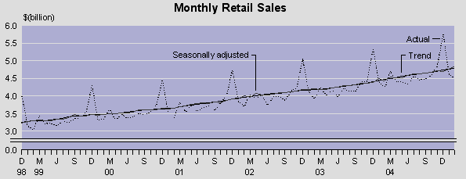
When does retail spending peak each year? Why? Retail spending increases during Christmas each year as people buy more goods and services.
2 Goods or services that were originally thought of as luxuries (such as electric powere, running water, fridges, TV’s and DVD’s) are now commonplace. In some cases they are even thought of as necessities.
3. Consumers have more access to credit and are often exposed to a lot of advertising by retailers and credit card companies to spend on credit. This encourages an increase in the overall level of household spending.
4. Increasing commercialization of lifestyles and religious festivals. For example the amount of advertising and spending that occurs during Christmas.

5. In the past households tended to spend most of their income on necessities and basic services. These days, consumers tend to have a far more materialistic lifestyle, with many households having both partners working in order to buy all the things that they want.
Zip zap, it's a path to penury 19.02.05 by Diana Clements NZ Herald
New Zealanders think plastic is fantastic and are big on borrowing. So big that we owe $1000 on credit cards alone for every man, woman and child in this country, says cardwatch.co.nz.
Our total debt including mortgages, hire purchase, personal loans and other credit has leapt to $114 billion compared with $25 billion in 1990. Removing mortgages from the equation, we still owe more than $10 billion to banks and other financial institutions. In short, there's a lot of Kiwis with debt problems.
Many start out with student debts - which amount on average to $14,242. Once out of university, many people fall in love with spending and it's a slippery slope to debt disaster. That's the easy bit.
Ditching debt is where it gets difficult and, like dieting, it's easy to think that just one more chocolate, or a new pair of shoes are a flash in the pan compared with thousands of dollars of debt.

THE RELATIONSHIP BETWEEN HOUSEHOLD INCOME AND CONSUMPTION PATTERNS.

If households are ranked according to the level of their income and this ranking is matched to types of household consumption, we see a clear pattern emerging.

- Group 1 consists of basic goods essential to provide a minimum standard of living. Households with low levels of income spend most of their money on this group of goods.
As aggregate income rises, the consumption of basic necessities (like basic food, clothing and shelter) also rise. But after a time the increased expenditure on these items tails off. For example, although we consume better quality food which is more expensive, we can still only eat so much. The same applies to clothing and housing. As income increases expenditure on this category of goods increases, but at a relatively slower rate until eventually the changes become minimal.
- Group 2 includes basic services such as transport and power.
The demand for transportation is likely to continue to rise for longer than basic necessities. Expenditure on public transport may not change greatly, and may even decrease as aggregate income rises. However, this is more than made up by the purchase and use of cars. With higher income, households can afford to own several cars.
- Group 3 Luxury goods and services.
Households with relatively higher levels of income do not spend a lot more on basic needs; instead, an increasing proportion of their income is spent on goods and services in Group 3. These include services that we may class as luxuries – holidays, recreation, or going to a concert. There is no limit to recreational spending. As people’s incomes increase they will spend a lot more on going to restaurants, going on holidays etc.
- Group 4 Savings.
Households on higher incomes do not spend all of their money and are able to save.
In conclusion we can predict that
- An increase in income will lead to an increase in spending on luxury goods and savings.
- During an economic boom spending on luxury goods will increase as incomes increase. Savings will also increase but spending in groups 1 and 2 will remain mostly unchanged.
- During a downturn spending on luxury goods will decrease and savings will also decrease as incomes fall. Spending in groups 1 and 2 will remain mostly unchanged.
AGGREGATE PATTERNS OF HOUSEHOLD EXPENDITURE
Low Incomes Middle Incomes High Incomes
Group 4
Savings

Group 3
Luxury goods and services.

Group 2
Basic services

Group 1
Basic necessities

Level of expenditure

Level of income

Average Weekly Expenditure (1)
by Income Group of Household
Year ended June 2009
Expenditure Group | Annual Household Income ($) (2)
 | Under $22,900 | $30,900 to $42,399 | $81,100 to $102,299
Food Group | 102.10 | 195.60 | 231.40
Housing Group (rent, mortgage etc) | 95.20 | 117.20 | 287.70
Household Operation Group (power, telephone, furnishings etc) | 155.80 | 171.40 | 254.70
Apparel Group | 11.70 | 23.00 | 48.90
Transportation Group | 51.50 | 88.10 | 160.70
Other Goods Group (tobacco, alcohol, medical goods etc) | 47.90 | 58.00 | 91.00
Other Services Groups (education, leisure etc) | 58.50 | 79.60 | 170.60
Total Net Expenditure | 522.70 | 732.90 | 1245.00

What happens to spending on luxury goods as income increases? Spending on luxury goods increases as income increases.

- Which group is managing to save money? People on higher incomes are managing to save money (income group 51 100 to 62 299.
- Which group is spending more than it earns?
How is this possible? People on lower incomes are spending more than they earn. They do this by borrowing money.

- Which group sees the biggest increase in spending as income increases? Other goods and services (luxury items ) sees the largest increase in spending as income increases.

- Billy Bob Bailey loves fried chicken and eats it as often as he can. During a recent visit to the big smoke Billy Bob found that the price of fried chicken was $3 a piece and so he bought 4. He was a little upset the price had gone up since last time he had visited when the chicken cost $2 a piece and he had been able to eat 7 pieces. Billy Bob would like to be able to eat more chicken but he would need the price to come down for him to be able to afford more. If the price came down to $1.50 he would buy 9 pieces and if he was lucky and the price was only $1 a piece he would buy 12 pieces.
a) In the space below create a demand schedule for Billy Bob.
BILLY BOB BAILEY’S DEMAND SCHEDULE FOR CHICKEN
P($) | QD (pieces)
1.00 | 12
1.50 | 9
2.00 | 7
3.00 | 4
b) On the grid below draw a graph showing Billy Bobs demand for chicken.
BILLY BOB BAILEY’S DEMAND FOR CHICKEN
D2
P($)

3.00

2.50

2.00

1.50

1.00
D

P2

P1
0 2 4 6 8 10 12 14 QD (pieces)
Q2 Q1

c) On the graph you have drawn on the previous page show what would
happen if the price of chicken pieces increases from $1.50 to $2.50.

- What has been the impact of the price change?
Describe what has happened. Price has increased and the quantity demanded has decreased.
Explain what has happened With an increase in price Billy Bob can no longer afford to buy as much chicken and so the quantity demanded has decreased.
Relate it back to the situation So with the increase in price from $1.50 to $2.50 the quantity demanded has decreased from 9 pieces to 6 pieces.
- On the graph you have drawn above, clearly show the effect of an increase in income on Billy Bob’s demand for chicken.
- What has been the impact of the increase in income.
Describe what has happened. Income has increased and demand has increased, shifting to the right.
Explain what has happened With an increase in income Billy can afford to buy more ( is able) and so his demand has increased and his demand curve has shifted to the right.
Relate it back to the situation Because Billy’s income has increased his demand for chicken has also increased because he can afford to buy more and so he now buys more chicken shifting the demand curve right.
- Complete the following sentences
a) A movement along a demand curve can only be influenced by a change in ___price_________ and this will cause a change in the _quantity demanded____________
b) A change in income will cause a _shift___ of the __demand____ curve and a change in __demand_________. Other factors that can cause a __shift___ of the curve are things like changes in fashion__________ and a change in Income __tax_____. Producers also try to increase consumers demand through Advertising_________________________ .
4. Define each of the following terms.
i) Substitute good a good that is use instead of another good.

ii) Complementary good a good that is used together with / in conjunction with another good
  - If the price of a substitute increases then demand for the original good will ___increase______________.
  - If the price of a complementary good increases then demand for the original will _decrease_______________.

  - What is aggregate household spending? Total average household spending.
  - If incomes increase then what will happen to the demand for inferior goods?
Demand will decrease.
9. On each of the graphs below clearly show what will happen in the following situations.

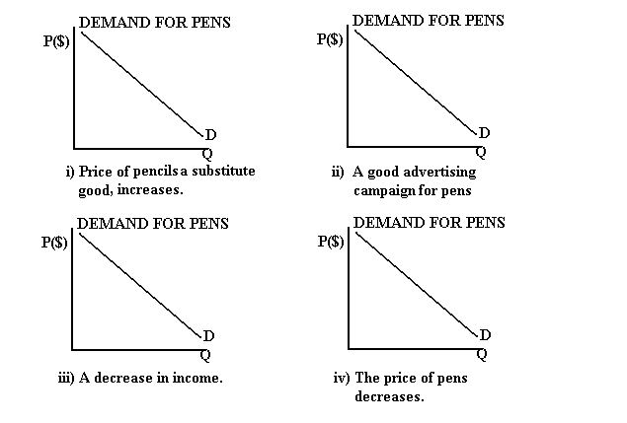
D2
D2
D2
P1
P2
Q2 Q1

10. Jen’s whänau has a weekly disposable income of $1200. Her friend Kirstyt’s whanau has a lower weekly disposable income of $400. Each household’s spending pattern is described in the table below.

% of Weekly Household Expenditure
Item | Grace’s Family  (Income $400) | Amy’s Family  (Income $1200)
Food  Housing  Household operation  Apparel  Transportation  Other goods and services  Savings  Total | 20.6  20.9  14.9  2.8  18.7  16.7  5.4  100.0 | 13.2  17.8  12.1  3.0  12.6  25.8  15.5  100.0

- Which items does Graces’s family spend a greater percentage of their income on? HOUSING AND FOOD
(b) Use the data above to analyse how each of the factors below will change as income increases.
Give a reason for each change.

(i) The percentage of income spent: AS INCOME INCREASES FAMILIES CAN AFFORD TO SAVE MORE AND SO ALTHOUGH THE TOTAL AMOUNT OF MONEY SPENT MAY INCREASE AS A PERCENTAGE OF INCOME MONEY SPENT MAY DECREASE.
(ii) The percentage of income saved: AS INCOME INCREASES PEOPLE CAN NOW AFFORD TO SAVE MORE AND SO SAVINGS INCREASE AND AS A PERCENTAGE OF INCOME THEY INCREASE BY A LOT.
(c) Why does the percentage of income spent on food fall as income increases?
FOOD IS A BASIC NEED AND ALTHOUGH THE TOTAL AMOUNT OF MONEY SPENT ON FOOD MAY INCREASE, AS A PERCENTAGE OF TOTAL INCOME SPENT IT DECREASES.
(d) Why would Grace’s family spend a greater percentage of their income on food and housing? Food and housing are necessities and people on low incomes spend a large proportion of their income on necessties.

11. Use the information below to answer the questions which follow
Zac is a fitness fanatic and wants to go to the gym as often as he can afford to. He calculates that at a price of $10 per visit he would go once a week. If the price was $7 he could afford to go twice a week and if the price was $5 he would go 3 times a week.
When he goes to the gym he finds that the price is only $2 and he goes five times per week.

- On the axes below, draw a graph showing Zac’s demand for gym visits.
ZACS DEMAND FOR GYM VISITS
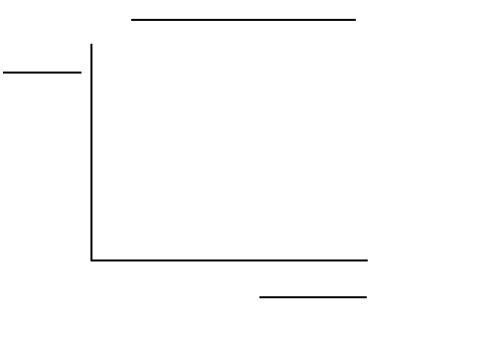
P($)
QD (VISITS PER WEEK)

10.0

8.00

6.00

4.00

2.00
0 1 2 3 4 5 6 7
D
P2

P1
Q2 Q1
D2

- On the above graph clearly show what will happen to Zac’s demand if the price of gym visits goes from $2 to $8.
- What has been the impact of the price change?
Describe what has happened. The quantity demanded has decreased.
Explain what has happened As the price has increased from $2 to $8 Zac can’t afford to go to the gym as often.
Relate it back to the situation With the increase in price from $2 to $8 the quantity demanded has decreased from 5 visits a week to less than 2 visits a week because he can’t afford to go as often.

- On the above graph clearly show what will happen if Zac’s income decreased.
- What has been the impact of the change in income?
Describe what has happened. Demand for gym visits has decreased.
Explain what has happened Income has decreased so Zac cannot afford to go to the gym as often.
Relate it back to the situation With Zac’s income decreasing he cannot now afford to go to the gym as often and so his demand for gym visits has decreased, shifting the demand curve left.

- What is the only factor that can cause a movement along the demand curve?
Price.
  - Define consumer demand.
IT IS WHAT A CONSUMER IS BOTH WILLING AND ABLE TO BUY AT A GIVEN PRICE, ASSUMING CETERIS PARIBUS.

  - Explain how the market demand curve is calculated.
IT IS THE HORIZONTAL SUMMATION OF EACH INDVIDUAL CONSUMERS DEMAND AT EACH PRICE.

  - If consumers decrease their demand, what are the implications for firms producing the good or service demanded?

IF CONSUMERS DECREASE THEIR DEMAND THEN FIRMS PROFITS WILLL DECREASE AS THEY SELL LESS AND EMPLOYMENT MAY DECREASE.

  - Complete the following table for the market for petrol in New Zealand, by ticking the appropriate boxes, and giving a reason for each. The first one has been done for you.

Change in Market for petrol | Demand increases:  movement along the demand curve | Demand decreases:  movement along the demand curve. | Demand curve shifts to the right | Demand curve shifts to the left | Reason / Explanation
The price of CNG falls markedly. |  |  |  |  | Price of substitute good decreases.
Price of petrol falls. | ✓ |  |  |  | Price of good decreases so QD increases.
Car ownership increases in New Zealand |  |  | ✓ |  | Increase in demand for a complement so demand increases.
Consumers income falls |  |  |  | ✓ | Incomes fall so consumers can’t afford to buy as much.

16. Complete the table below filling in all missing figures.

OLIVER’S DEMAND SCHEDULE FOR PASSIONFRUIT FUDGE
Price ($ PER PIECE) | QD (PIECES)
$0.50 | 10
$1.00 | 8
$1.50 | 6
$2.00 | 4
$2.50 | 3
$3.00 | 0

- Using the information in the demand schedule and the grid below, construct a market demand curve for passionfruit fudge.
Oliver’s demand for passionfruit fudge

P($/piece)

3.00

2.50

2.00

1.50

1.00

0.50
P2

P1
D2
D
0 2 4 6 8 10 12 QD (pieces)
Q2 Q1

- On the graph clearly show what will happen if the price of passionfruit fudge goes from $1 to $2.50.
- What has been the impact of the price change?
Describe what has happened. The price has increased and the quantity demanded has decreased.
Explain what has happened Because the price has increased the quantity demanded has decreased because Oliver can’t afford to buy as much fudge.
Relate it back to the situation The price of fudge has increased from $1 to $2.50 and Olivers quantity demanded has decreased from 8 pieces to 3 pieces.
- On the graph you have drawn above, clearly show the effect of an increase in advertising on the demand for passionfruit fudge. In this colour.
- What has been the impact of the advertising campaign?
Describe what has happened. Demand has increased.
Explain what has happened With increased advertising Oliver is more willing to buy passion fruit fudge and so demand increases.
Relate it back to the situation The increased advertising will increase Oliver’s demand for passion fruit fudge and so demand increases because Oliver is more willing to buy more pieces of fudge.

17. Underneath the graphs below write a likely explanation for the changes which have
occurred. 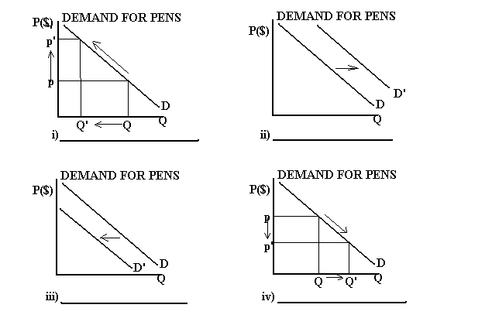
Increase in price
Decrease in price
Increase advertising, increase income etc
Decrease advertising, decrease income etc

18.

Aroha enjoys listening to music and regularly buys songs from itunes. Her monthly demand for songs is shown on the schedule below.

Aroha’s Monthly Demand for Songs |  | 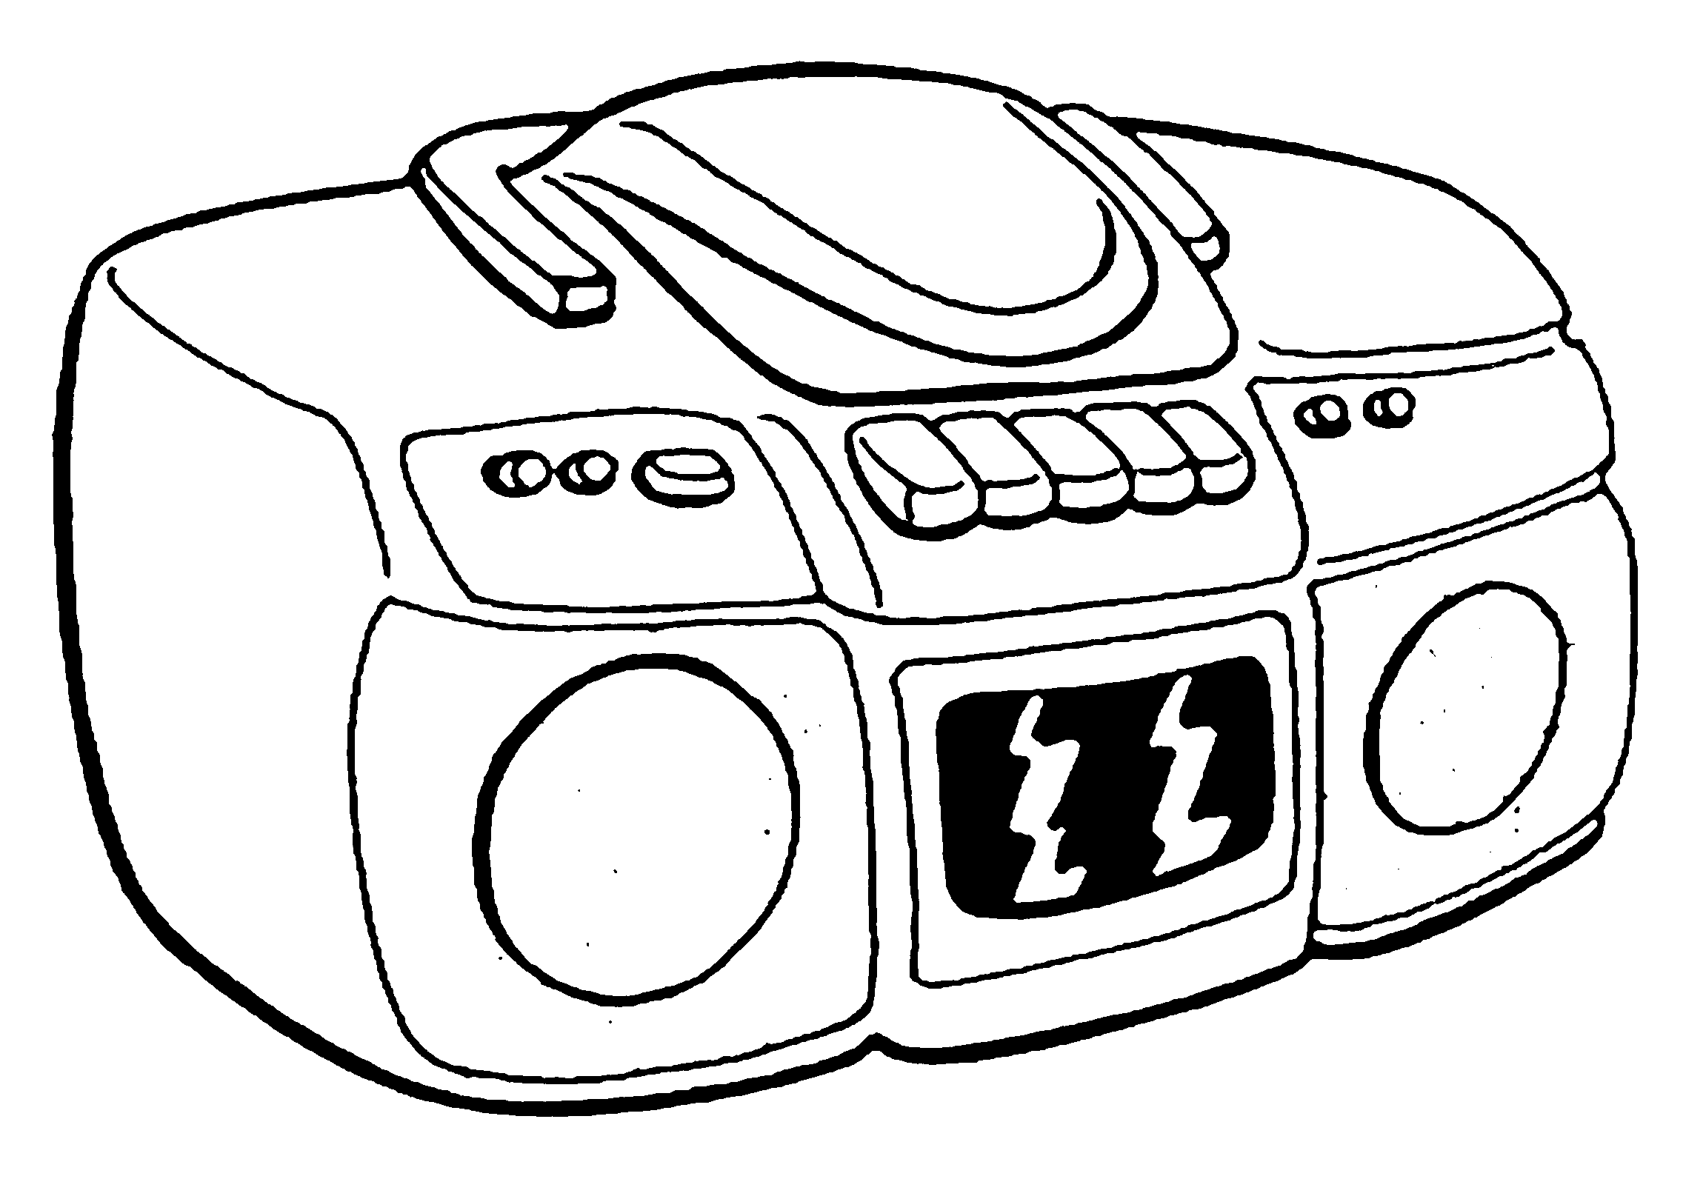
Price ($) | Quantity
1.50 | 2
1.30 | 3
1.10 | 4
0.90 | 5
0.70 | 6

(a) From the information in the demand schedule above, draw a labeled demand curve.
Aroha’s Monthly Demand For Songs

P($)

1.50

1.30

1.10

0.90

0.70

P2

P1
D
0 1 2 3 4 5 6 QD
Q2 Q1

(b) Indicate on the demand curve you drew for Question Two (a) the effect of a price increase from $0.90 to $1.20.
(c) Explain how the demand curve illustrates the Law of Demand.

It shows as the price increases the quantity demanded decreases.

19.
Aroha goes fishing whenever she can.
Aroha’s Weekly Demand for Bait
10

9

8

7

6

5

4

3

2

1

Price
($ per kg)

Price  ($ per kg) |  |  |  |  |  |  |  |  |  | D2
Price  ($ per kg) |  |  |  |  |  |  |  |  |  | D
Price  ($ per kg) |  |  |  |  |  |  |  |  |  | Quantity  (g)
 | 0 100 200 300 400 500
Fig. 1

(a) Use the information from Fig. 1 to construct a demand schedule below that shows Aroha’s weekly demand for bait.

AROHA’S WEEKLY DEMAND SCHEDULE FOR BAIT
P($) | QD (grams)
8 | 100
6.50 | 150
3 | 350
2 | 450

(b) Indicate on Fig. 1 the effect of an increase in Aroha’s demand for bait.

(c) Give TWO possible causes of an increase in Aroha’s demand for bait.

Good advertising, increase in income, increase in the price of a substitute.

20.

Aroha also likes to watch DVD’s and go to the movies. She usually hires at least one DVD each week, but may hire up to five.

For each of the following events, explain what would happen to Aroha’s demand for DVD’s.
Give a reason for each answer.

(a) The price of going to the movies rises.
Describe what has happened. The demand for DVD’s will increase.
Explain what has happened The price of a substitute has increased and so movies become relatively more expensive and so Aroh’s demand for DVD’s increases.
Relate it back to the situation

(b) Aroha has to spend more time on her homework.
Describe what has happened. Aroha’s demand for DVD’s will decrease. Due to limited means (time) Aroha now has less time to watch DVD’s and so her demand for DVD’s will decrease as she is not able to watch as many.

(c) Aroha decides to increase her savings.
Describe what has happened. If Aroha decides to increase her savings then she will have less money available for spending (consumption). Income can either be saved or spent, if savings increase less income is available for consumption and so Aroha’s demand for bait will decrease shift the demand curve left.

21.

Aroha is a consumer of fishing rods, mountain bikes, CDs, bait, DVD’s and movies.

(a) Explain how Aroha might react as a consumer, in the short term and long term, if a temporary ban is put on fishing because of a chemical spill in the local waterways.
Describe what has happened. In the Sort Run - Because of the ban Aroha can no longer go fishing and so her demand for bait – a complementary good, will decrease.
With this decrease in demand Aroha may spend more on other things such as CD’s and DVD’s so her demand for these things will increase.
In the long – run there will be no ban and so her demand will go back to what it was before.

(b) Explain how Aroha might react as a consumer, in the short term and long term, if she is selected for a representative hockey team, requiring her to practise twice more during the week than she currently has to and to travel away on Saturdays.
Describe what has happened.
Explain what has happened
Relate it back to the situation

Aroha also likes to hire games for her Playstation. These games have been falling in price.

(c) On the diagram below show how the decrease in the price of hiring Playstation games will affect Aroha’s demand curve for DVD’s.

Aroha’s Demand For DVD’s

- What is the impact of this change?
Describe what has happened.
Explain what has happened
Relate it back to the situation

22.
Huriana likes to go to the movies. The current price is $8.00 and she goes once each month. Huriana would go four times each month if the price was only $4.00 but would only go two times each month if the price was $6.00. Huriana would not go at all if the price rose to $12.00.
- Use the information in the passage above to draw Huriana’s demand curve for movie tickets. Fully label your graph.

Huriana’s friend Aroha sometimes goes with Huriana to the movies but she prefers to watch movies on DVD at home.
(b) (i) On Graph 1, below, sketch the likely impact of a fall in the price of movie tickets on Aroha’s demand for movie tickets. Use appropriate lines, labels and arrows.

Describe what has happened.
Explain what has happened
Relate it back to the situation
(c) (i) On Graph 2, below, sketch the likely impact of a fall in the price of movie tickets on Aroha’s demand for DVDs. Use appropriate lines, labels and arrows.
Aroha’s Demand for DVDs

Graph 2
Describe what has happened.
Explain what has happened
Relate it back to the situation
(d) List TWO causes (other than changing the price of substitutes for DVDs) that could shift the demand curve for DVDs to the right, ie increase the demand for DVDs. For EACH cause, give ONE reason to explain why the demand curve will shift to the right.
Cause 1:
Reason:
Cause 2:
Reason:

23.
(a) Graph 3 shows that even when households earn no income, they still spend money on goods and services. How can they do this?

(b) Examine the pattern of household spending on necessities shown on Graph 4 and then:

(i) the trend shown on the graph
(ii) provide TWO reasons for the changes in spending on these goods as household income increases.

(i) Spending trend:
(ii) Reason 1:

Reason 2:
(c) Examine the pattern of household spending on inferior goods shown on Graph 5 and then:

(i) describe the trend shown on the graph
(ii) provide TWO reasons for the changes in spending on these goods as household income increases.

) Spending trend:
(ii)Reason 1:
Reason 2:

(d) (i) On the axes provided below, carefully sketch the pattern of spending on luxuries as household income increases.

(ii) Analyse how the pattern of spending on luxuries changes as the level of household income increases.

